**Project 1**

**Bank Marketing Analysis**

**Abstract**

There is a Portuguese banking institution which organizes several marketing campaigns and they want to understand the customers behavior towards various campaigns based on different factors using past data in order to better understand the customers and improve the business profit.

**Tools / Skills Used**

1. Python Programming

2. Jupyter Notebook

3. Pandas

4. Numpy

5. Matplotlib

6. Seaborn

7. Exploratory Data Analysis

8. Data Visualization

9. Feature Selection

10. Parameter Optimization

11. Machine Learning

12. Tableau

**Implementation**

**Workflow:**

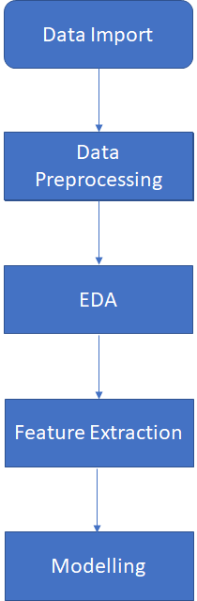

Data Import - In every data science project this is the first step performed. Here we import the data from the desired location into the current working environment.

Data Preprocessing - This is the step after data import where we figure out the anomalies present in the data in the form of missing values, incorrect values etc and try to deal with it using various techniques like: dropping null values, filling null values using statistical measures i.e mean, median in case of numerical data and mode in case of categorical data.

EDA(Exploratory Data Analysis) - In this step we try to understand different features and their relationship among other features present in the data by plotting different charts and using data manipulation tools. This step plays a crucial role in understanding the data.

Feature Extraction - Using this step we figure out the features that are important for our model by ranking them based on the evaluation criteria. Using this method, we eliminate the features that are important in terms of modelling.

Modelling: In this step the data is splitted into train and test set for validation and then the model is built using train dataset and goodness of model is checked using test dataset.

**Code Snippets**

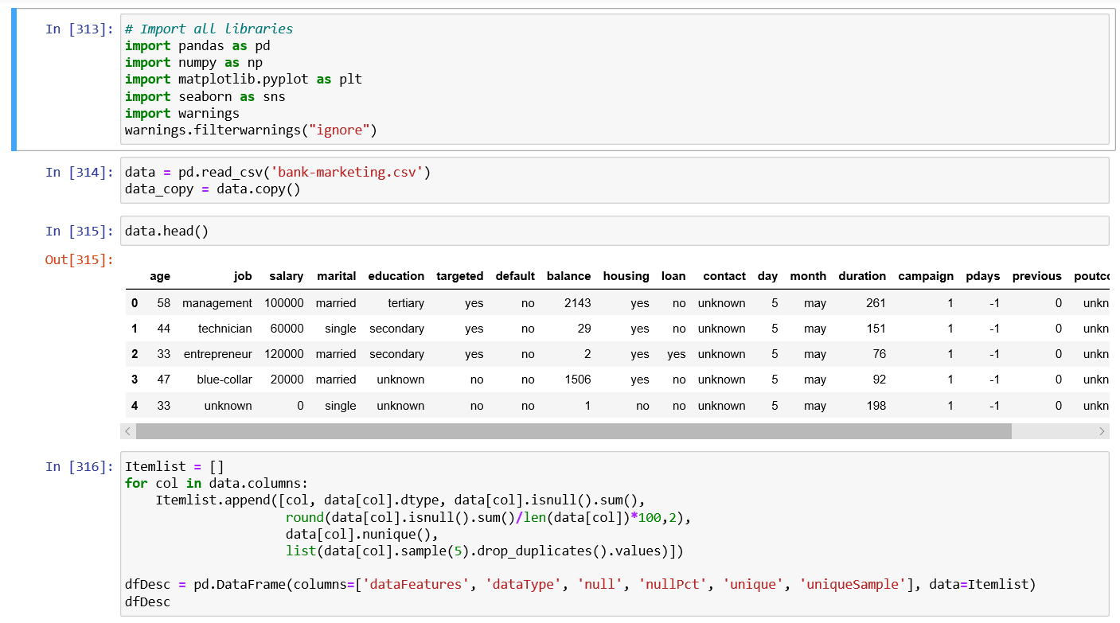

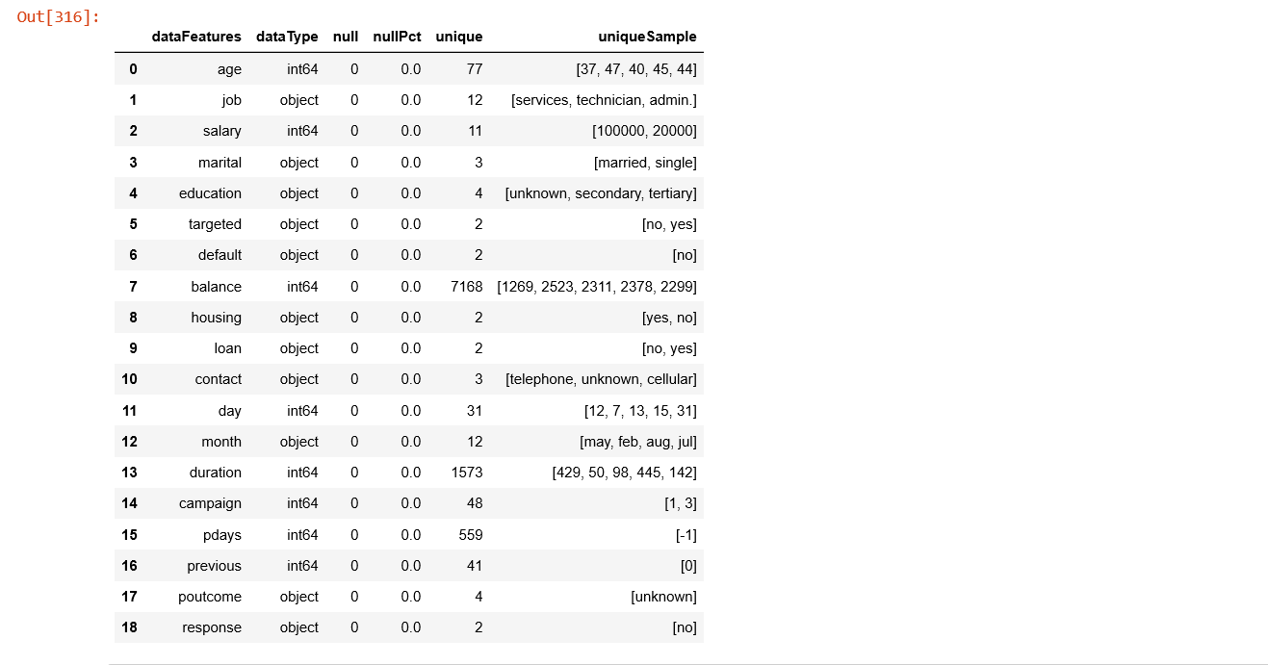

**Visualization Snippets:**

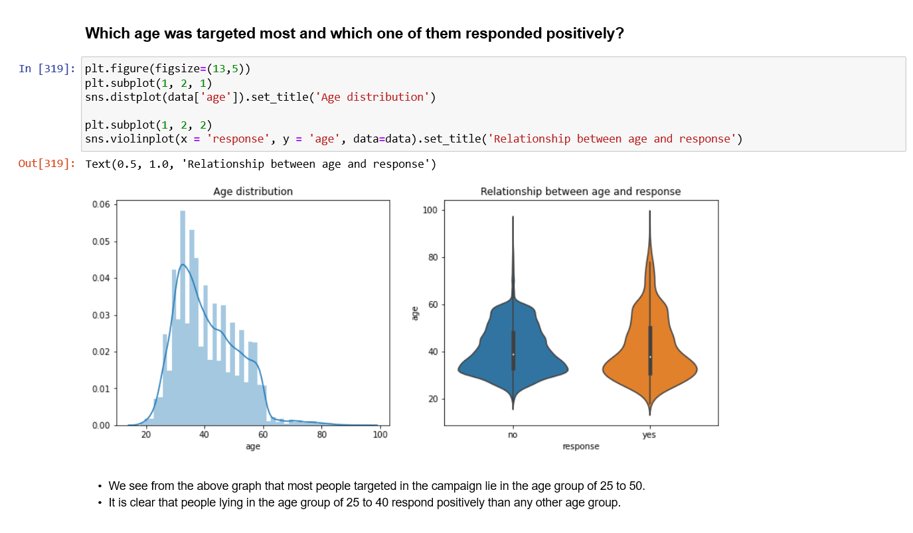

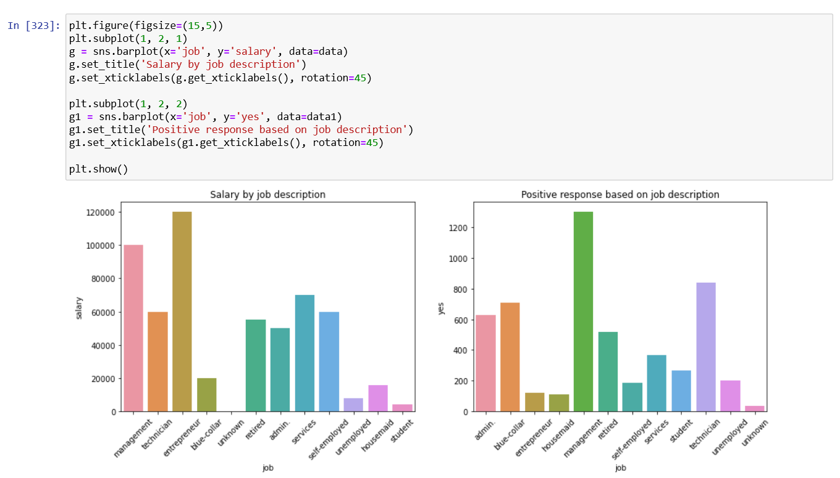

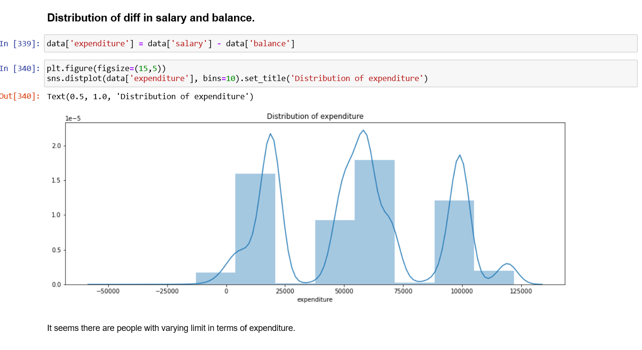

**Modelling Snippets:**

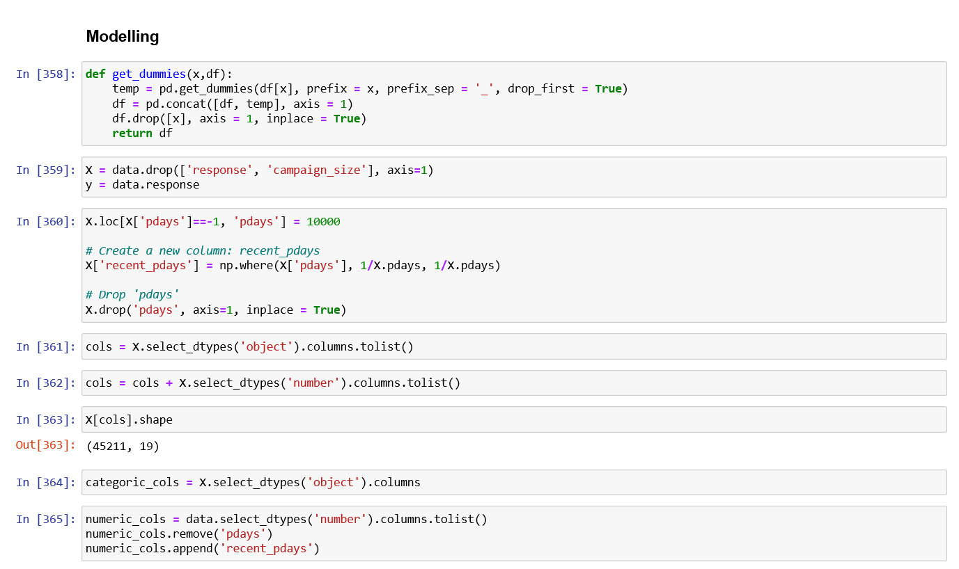

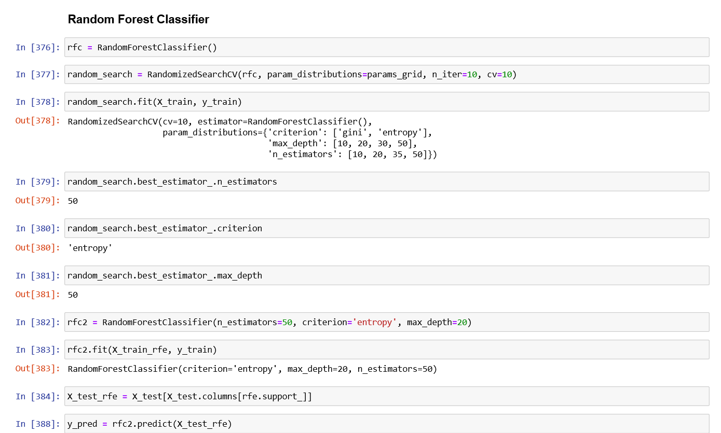

**Tableau Dashboard Snippets:**

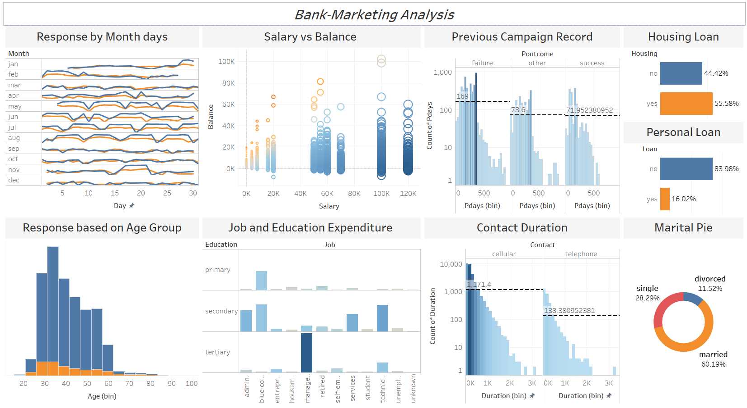

**Conclusion / Results**

As a result, we can say the marketing team should consider age, salary, balance, duration, campaign and marital status before targeting a customer for better response.

**Future Scope**

Further, the data driven decision can be improved by implementing other machine learnings algorithms.